- Sign in with your existing details (Email Address / Password) – there is a Forgotten Password button if you have forgotten your password
Instructions for Students – Updating account details when moving to a new school / college Students – Updating account details when you move school / college
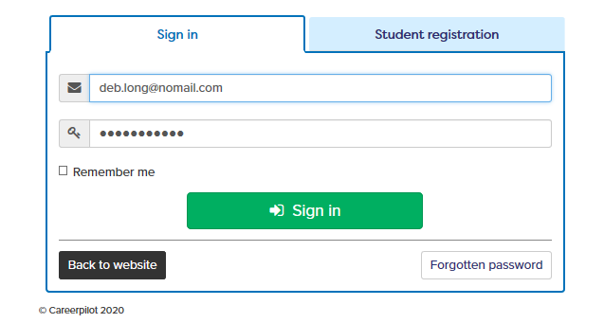
- Click on your name at the top right of the Home Page
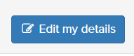
- Click on My Details and then Edit My Details

- Update your details – select your new school/ college. You could also change your email address if necessary.
NOTE: Your year group will automatically move up a year on the 31st August so no need to change.
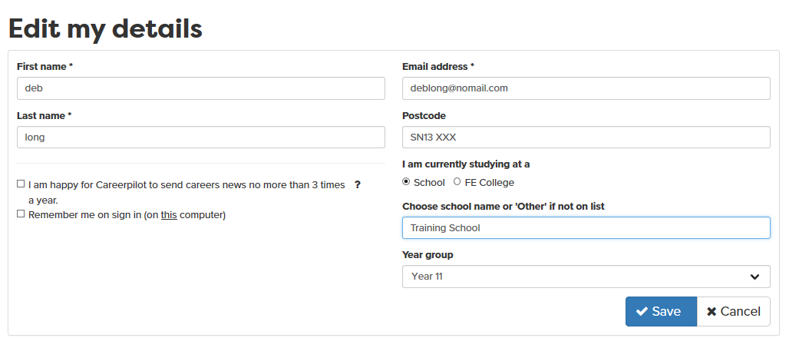
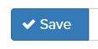
- Don’t forget to Save your changes

