Free websites which will help young people explore their choices and make informed decisions about their future career options.
Hyperlink version for use on websites, email, etc.
General Careers Advice for 13- 19 year olds
The Careerpilot website aims to provide 13-19 year olds in the South West with information on the full range of choices available at 14, 16 and 18, including apprenticeships, college, higher level study, etc.
The website also includes information on twenty job sectors, links to providers in the South West and, if users register (which is free, on the home page and takes 1 minute) they can save their choices of job sectors, providers and qualifications in Career Tools. Users can also save their results from the: Profile Builder and HE Skills Map (for post 16 students).
The new Parent Zone provider parents and carers with answers to career related questions www.careerpilot.org.uk/parent
The National Careers Service website contains over 750 job profiles, and each of them gives you the essential information you need on what the job involves and how to get into it. The site also has a job market information section about the job situation in your local area and you can also talk to an adviser.

The Future Morph website is designed to show 14 – 18 year olds career routes that studying science, technology, engineering and maths can lead to.

Careersbox is a free online library of careers related film, news and information

The Bright Knowledge site and the Student Calculator are designed to help students and young people manage their money and explore education and career options

Plotr offers information on different job sectors and careers-related information.

j

Information on post 16/18 training opportunities
 | For Gov.uk information and links for 14 - 19 year olds which includes information on apprenticeships, training, money and how to find one.
 | Careers World provides information on job sectors and has some job and apprenticeship vacancies. Also includes SW region facts and contacts.
 | notgoingtouni provides information on the opportunities available after school and shows vacancies for apprenticeships, employment, sponsored degrees, etc.
 | Plotr has information about job and apprenticeship vacancies.
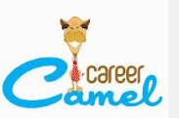 | Career Camel  A site for students, graduates and school leavers offering jobs, internships, advice and courses.  The site also offers an online CV Builder

Information on progression to university
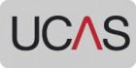 | UCAS is the organisation responsible for managing applications to higher education courses in the UK. Not only do UCAS process more than two million applications for full-time undergraduate courses every year, but they also help students to find the right course.
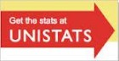 | Unistats is the official website for comparing UK higher education course data. It includes official data on each university and college's satisfaction scores in the National Student Survey, jobs and salaries after study and other key information for prospective students.
 | UK Course Finder is a good site to look at you have no idea what you might like to study. It has a subject’s interest questionnaire which provides degree subject suggestions based on your answers. You'll then be able to search for university courses relating to these subjects. You can also search for unis by the number of UCAS points
 | Best Course 4 Me (and their free app) is a good site to help planning a future degree. Users can identify A level subjects and see what degrees people usually go on to do, see what careers people progress on to from different degrees, etc.
 | The Which? university guide has lots of information and filters to help you find a course to suit your needs.
 | The Guardian University Guide has information on every subject taught at universities in the UK ranked in league tables, also has subject profile information.
 | Studential.com provides in-depth information about choosing and going to university and the application process involved.
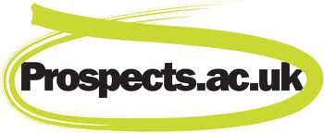 | Graduate Prospects is the UK’s leading provider of information, advice and opportunities to students and graduates. They publish a wide collection of journals and directories, as well as provide an extensive graduate careers website.

