cid:image001.png@01D38DE5.57DA2E20

January 2018

[www.careerpilot.org.uk](http://www.careerpilot.org.uk)

**User Guide for the ‘Keeper of the Password’ in schools and colleges**

This User Guide is designed to enable you as the Careerpilot ‘Keeper of the Password’ to discover more about the Careerpilot Reporting Zone and how it can be used in your school / college.

By following the steps within the User Guide you can find out how to:

1. view individual student reports
2. set up new groups
3. set up staff so that they can see reports
4. view group reports to show trends
5. download individual and group reports

**To access the Reporting Zone admin area you must sign in with the password sent to you by Careerpilot. You will be prompted to change the password.**

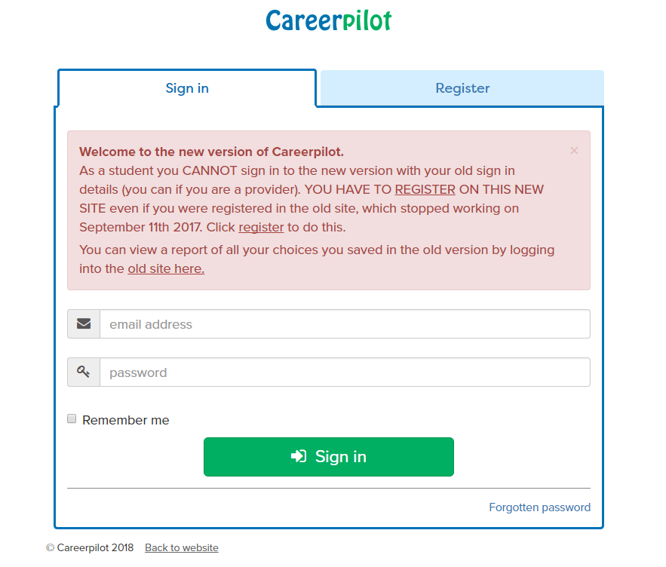

Once you are signed in you will see the Admin area.

Once in the admin area there are options available to you – this is where you can view reports, add groups and add other staff so they can view reports.

Note: You can switch back to the Student site at any point, by clicking on Student site.

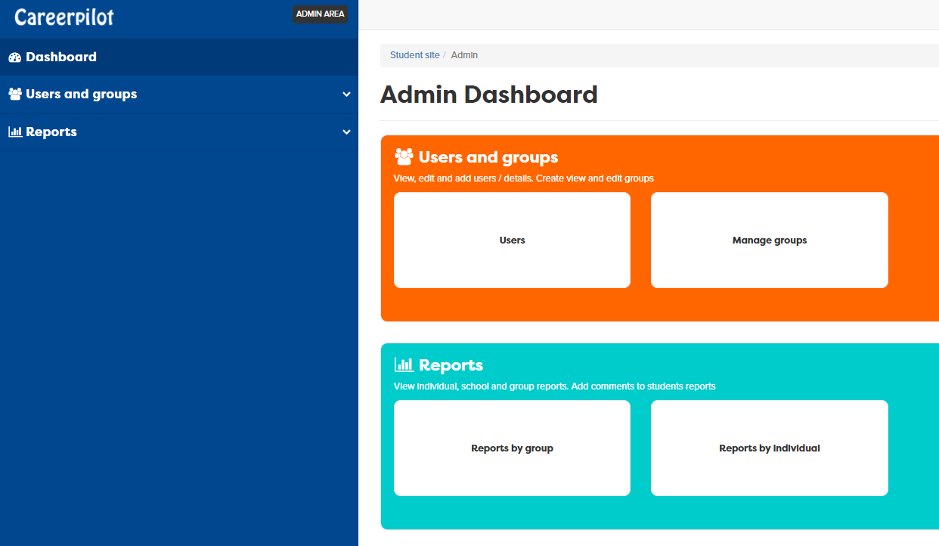

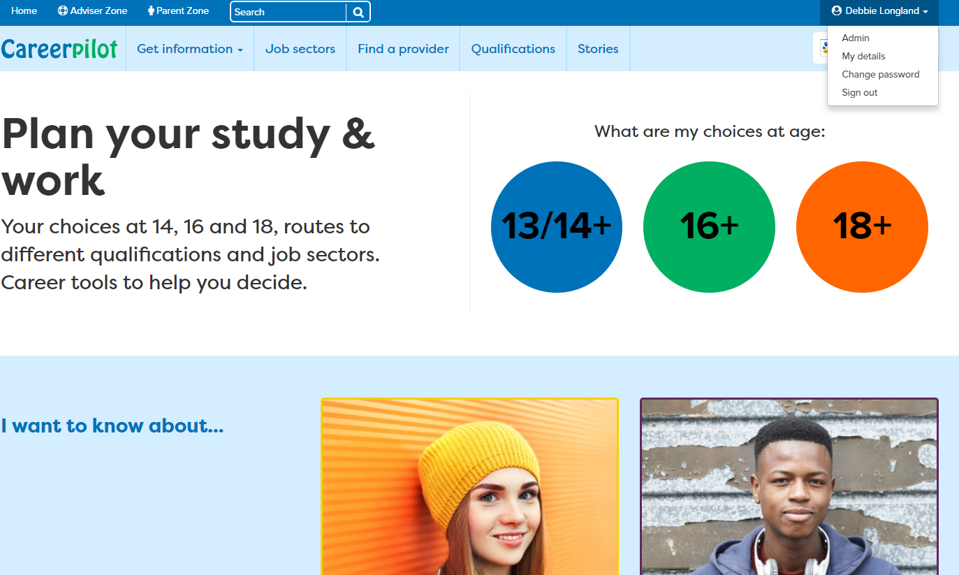

You can then get back to the Reporting Tool by clicking Admin

**1. Viewing individual student reports**

This is useful when you want to find out what choices an individual is interested in. You can view the report and add ‘Adviser Comments’ when necessary.

**2. Setting up new groups**

1. To access an individual student report:

**a)** **Click on Reports by Individual**

**b) Find the student whose report you would like to view. There are various filters that you can use**

**c) Click on Choose report**

**d) You have the option of viewing the whole report or a particular section**

**e) Choose ‘Adviser Comments’ if you would like to add a comment / feedback for the student**



When students register they assign themselves to a particular year group so in the admin area year groups are automatically collated.

If however, you need to set up your own groups, i.e. tutor group or groups of special interest you can do this in the admin area. You can also assign staff (if they have been set up) to view the groups.

33



2. To set up a new group:

**a)** **Click on Manage Groups**

**b) Select + New group in the top right**

**c) Assign your group a name**

**d) Assign any staff to the group as necessary by selecting their name(s).**

**e) Select the students who are in that group by selecting the students. Note: you can make the list smaller by filtering by year group.**

**f) Don’t forget to press the save button once you have finished (bottom of list)**

**3. Setting up staff so that they can see reports**

You **cannot** set up students as users as they register themselves on the student site. You can register staff users and then give them access to the groups they should view (Please be aware that this is student’s personal data and only give staff access to the groups they need to see )

3. To set up a member of staff:

**a)** **Click on Users**

**b) Click on +New User**

**c) Enter the details of the member of staff, including email address**

**d) Assign them the role of ‘teacher’**

**e) Click on Send Password**

**f) The password will be sent to the email address and needs to be activated by the staff member**

**NOTE: If somebody has already registered as a student using the same email address you will need to contact Careerpilot to change their status – see contact details at the end of the User Guide.**

**4. View group reports to show trends**

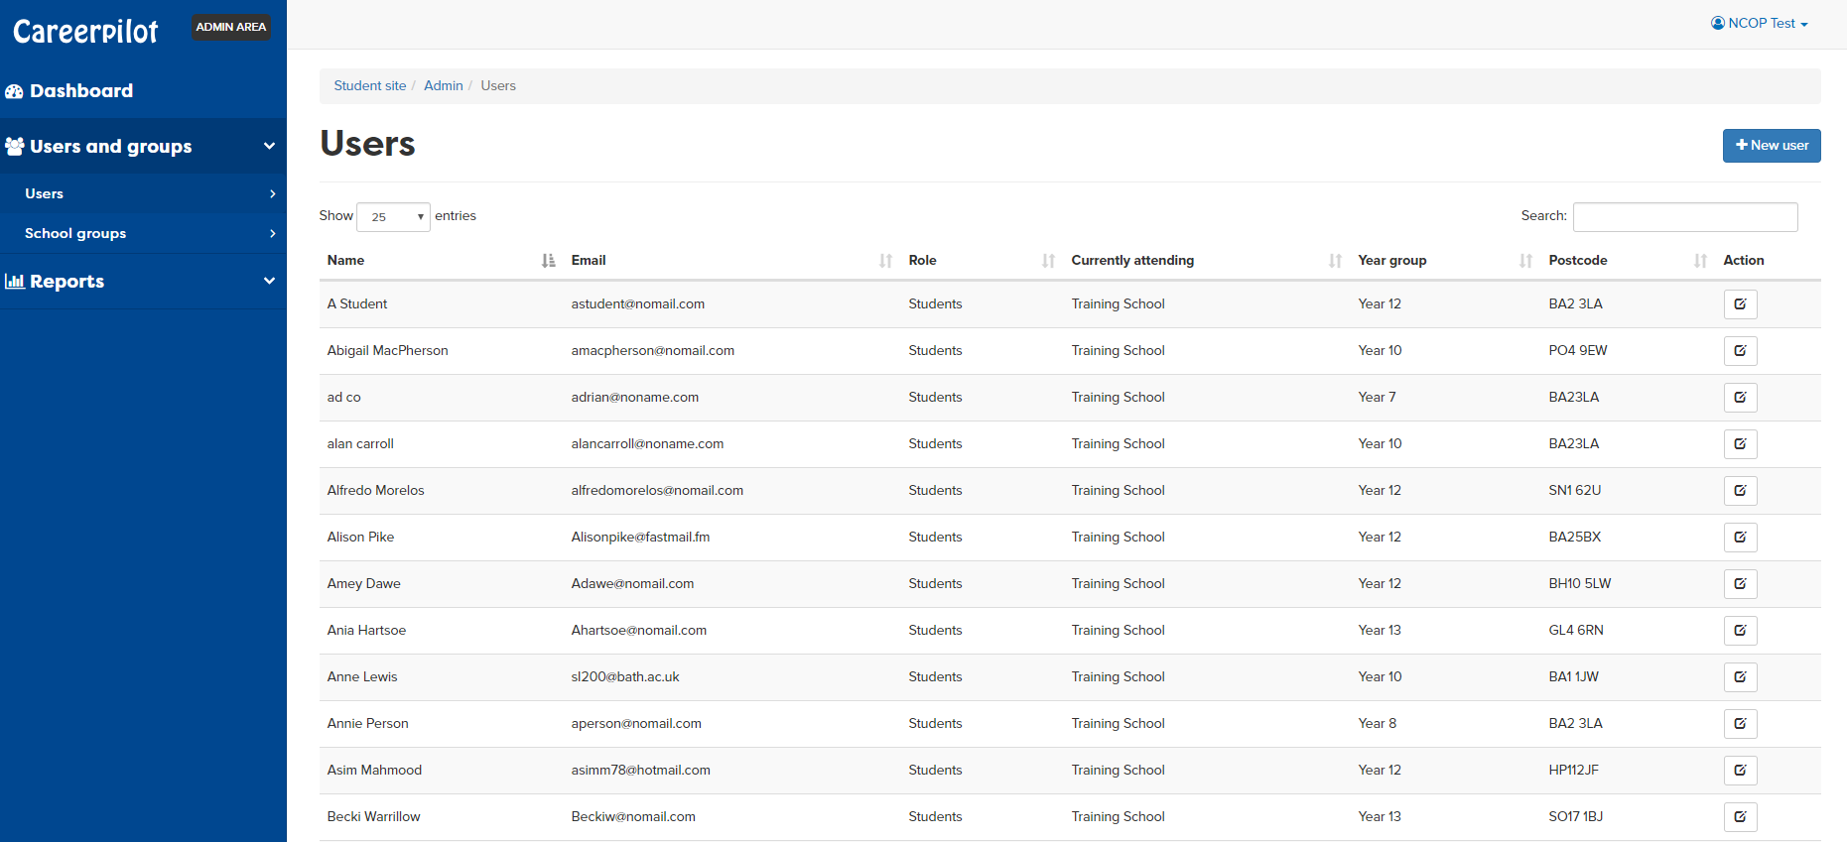

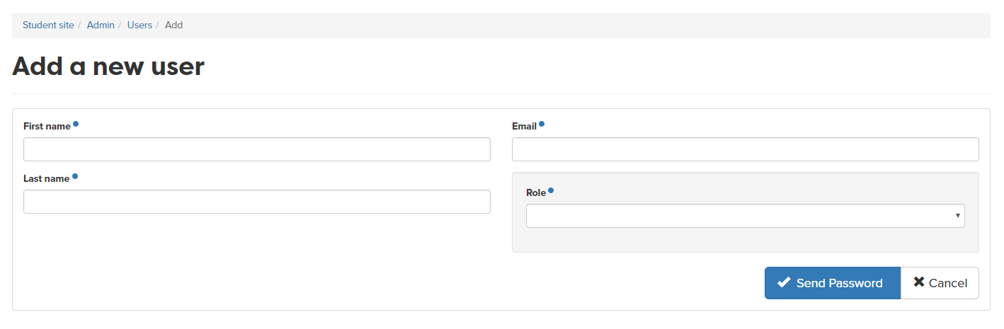

You can use the Reporting Zone to view group reports – this could be from the groups that you have set up yourself (see 2. Setting up new groups) or from existing groups i.e. a whole year group. This can be useful when deciding what interventions would be useful for a particular group.

E.g. if a particular university is popular you could organise a visit to that institution or if a particular job sector has been selected by a large number of students you could tailor the employer’s talk/visit to students interested in that sector. The Job Sectors report could also be useful when students are planning work experience

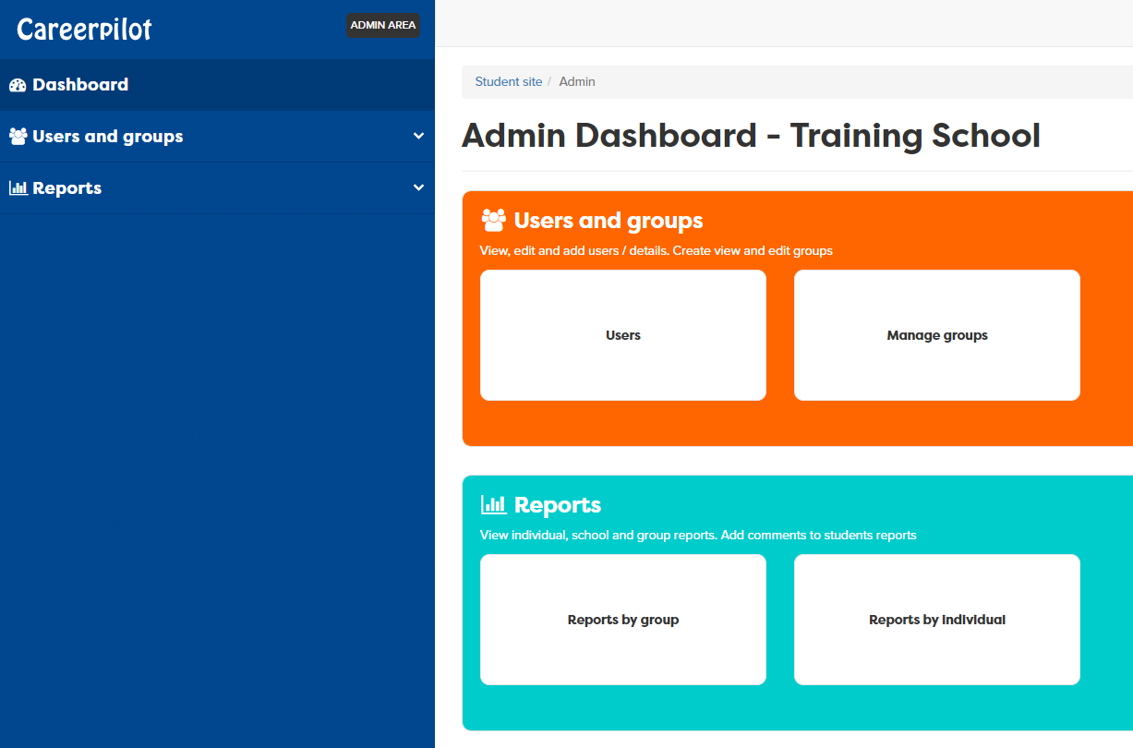



4. To view group reports

**a)** **Click on Reports by group**

**b) Select the group**

**c) Click on Choose report**

**d) You now have a choice of what you can view, including a report that shows you how many of the sections the students have completed.**

This report shows the providers that a group of Year 11 students have selected.

Dark blue ticks = Doing this Light blue ticks = Considering this Red ticks = Applied

This report shows the job sectors that a group of Year 11 students have selected.

Green ticks = Definitely interested Orange ticks = Just exploring

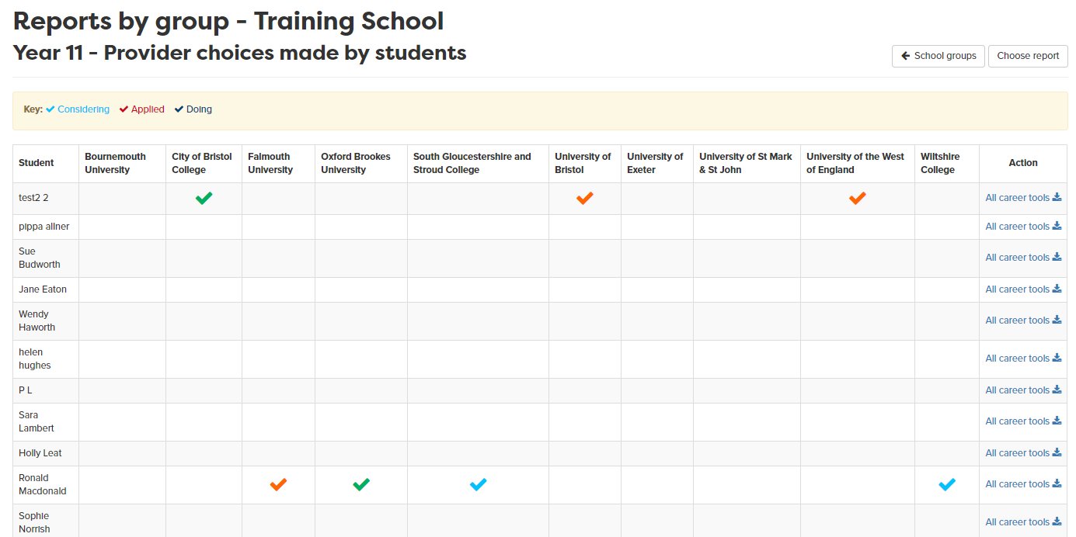

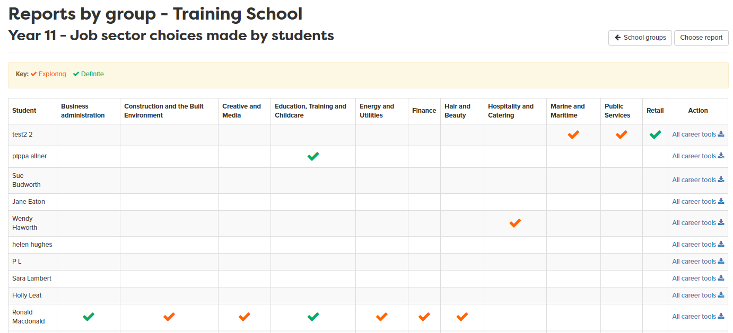

**5. Download group reports**

For each of the group reports that you view there is the option to download as an Excel spreadsheet that can be saved and edited as you wish. Simply scroll to the bottom of the report and click Download data.

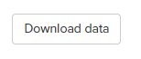

**Careerpilot Contact details**

If you need any assistance when using the Reporting Zone please don’t hesitate to get in touch:

**Careerpilot Helpline – 01225 386161**

**Careerpilot email address – careerpilot@bath.ac.uk**