Session Leader Guide KS5 Tutorial
Time: 25.5 mins
Slide 1 – Opening Slide 0.5 minutes
- Say: You’ve had an assembly introducing key Labour Market Information from West of England Combined Authority. We looked at Labour Market Demand and the skills employers in our region will want you to have.
- Say: In this tutorial session we will take a closer look at your skills and how you can use Labour Market Information to inform decisions around which skills to develop.
- Explain: Even if you are not totally sure about what job you want yet Labour Market Information gives us tools that can help when thinking about jobs, skills and careers.
Slide 2 – Aims for this Tutorial 0.5 minutes
- Go through the aims on the slide with students.
- Say: Our region, the West of England, has exciting job and career opportunities that you can take advantage of. However, to do that, you need to know which skills, qualifications and experiences the employers here are looking for. Labour Market Information provided by the West of England Combined Authority helps you to do this. Today we will focus on your skills.
Slide 3 – Outcomes for Today 0.5 minutes
- Go through the outcomes on the slide with the students
Slide 4 – What is a Skill? 0.5 minutes
- Ask: What is a skill?
- Action: Take some responses from students before clicking to reveal the answer
- Explain: There are different types of skills and we will look at these in more detail next.
Slide 5 – What are Hard Skills? 0.5 minutes
- Ask: What are hard skills?
- Action: Take some responses before clicking to reveal the answer.
- Go through the points on the slide.
Slide 6 – Hard Skills Demand 2 minutes
- Explain: On the right of this slide we can see the most frequently sought hard skills by employers in the West of England this Labour Market Information has been taken from job advertisements posted between July and September 2020.
- Say: You can see that Auditing skills were most frequently sought followed by Business Development and then Accounting. On the left of the slide is a further breakdown of some of the other skills that are sought after. IT skills feature in the top ‘hard skills’ demands from job adverts but when you look at the table the only IT skill listed is Javascript.
- Explain: IT skills are one of the most commonly sought skills as IT is used across most sectors and industries. So whilst Auditing is the most frequently sought skill, employers would also be looking for people with those additional IT skills and for some adverts may also be specific and ask for experience of certain software packages. Business Development is second in the table and again people who work within business development will also need experience of using customer relationship management software packages and/or databases which is IT skills again.
- Say: When you enter employment you will gain experience and skills by using the IT packages and software that that employer uses and you can take that experience and those skills with you to other employers and even employers in different industries or sectors.

Slide 7 – Exercise 1: What are your Hard Skills? 4 minutes
- Note: This exercise can be completed during the tutorial if time permits or given as a takeaway/homework. Handouts are at the end of this session leader guide.
- Ask: What are your hard skills?
- Explain: All of you have the hard skills shown on the right of this slide. From these write down an example of the hard skills you have for each category.
- Can you speak other languages?
- What qualifications do you have, not just your GCSE’s, do you have other qualifications or awards for example Duke of Edinburgh?
- Explain: Your English GCSE demonstrates to an employer that you have good communication skills both written and verbal. Your Maths GCSE demonstrates that you possess maths skills and nearly all employers will be looking for applicants that have both Maths and English GCSE’s
- Ask: Do you have any programming skills or experience of any software packages? (Highlight any software packages that are used within school/college)
- Explain: Some of the subjects you are studying or have studied have given you hard skills that you can demonstrate to an employer. When you enter the workplace you continue to build and develop your hard skills particularly IT or Digital skills.
- Say: At the end of this tutorial we will look at next steps which includes tools for you to check your skills in more depth in your own time. For now, do any of the hard skills you’ve written down as examples relate to those on the left which we know employers here in the West of England are looking for?
Slide 8 – What are Soft Skills? 0.5 minutes
- Ask: What are soft skills?
- Action: Take some responses before clicking to reveal the answer.
- Go through the points on the slide.
Slide 9 – Demand for Soft and Employability skills 2 minutes
- Explain: This slide shows the most frequently sought soft skills as advertised by West of England employers in job adverts between July and September 2020.
- Say: The most sought after soft skill is communication skills. When entering the world of work you will be communicating with colleagues, with customers and possibly other external people or companies such as suppliers, so being able to communicate confidently both verbally and in writing / email is seen as an important requirement by employers.
- Say: Some job roles have specific soft skill requirements such as Leadership or Management whilst others are more generic such as Enthusiasm and Planning.
- Say: Why is it important to know this West of England LMI? Employers here require a mix of qualifications (hard skills) and soft skills. Some employers view these as having equal importance. Whilst it is important to achieve your qualifications you also need to develop and build your soft skills so employers here will want you to work for them.
Slide 10 – Exercise 2: What are your soft skills? 4 minutes
- Note: This exercise can be completed during the tutorial if time permits or given as a takeaway/homework. Handouts at the end of this session leader guide.
- Ask: What are your soft skills?
- Explain: All of you will have some of the skills on the right of this slide. These soft skills can be developed and built through your studies, through volunteering, through part time employment, through involvement with sports or other clubs or activities both in and outside of school / college.
- Say: Write down the soft skills shown on the right then rate yourself from 1 to 5 as to how good you think you are for each. One is for “Need to Develop” this skill through to five which is ‘Strength for me”.
- Go through the examples on the slide
- Communication skills Do you listen effectively, ask questions and are you confident in introducing yourself to new people and talking about yourself?
- Team working skills Have you experience of working as part of a team or group?
- Organisational skills Do you plan your work, hand assignments in on time and are you punctual?
- Problem solving and analysis Do you analyse problems and develop a plan to solve them? Do you review information and/or think about your decisions and/or consult with others as part of that plan?
- Creativity Are you able to think of your own ideas and do you think of ways to improve something and explaining why?
5. Say: As mentioned in the hard skills exercise earlier, at the end of this tutorial we will look at next steps which includes tools for you to check your skills in more depth in your own time. For now, do your soft skill ratings relate to those on the left which we know employers here in the West of England are looking for, which do you need to strengthen?
Slide 11 – What are transferable skills 1 minutes
- Ask the question on the slide and gain some responses before clicking to reveal the answer.
- Go through the points on the slide.
Slide 12 – Transferable and commonly sought skills 2 minutes
- Explain: West of England Combined Authority LMI tells us there are transferable skills in demand by employers in our region, this includes traditional vocational roles in the Human Health and Social Work and Transportation and Storage Sectors.
- Say: Key areas of high demand skills include
- Go through and read out details on the slide
- STEM subjects are the basis of many technology jobs
- Digital/technology skills are important not only in the resilient IT, creative and digital sectors in the West of England but across many other jobs
- Business Skills such as being able to sell and manage people are applicable across many jobs
- Specific vocations, people with skills relating to specific jobs are currently in demand, think of people who trained to drive HGV or care workers and nurses.
4. Say: Labour Market Information like this is important for you to know as it shows you what employers are looking for, you can then use this to inform your choices relating to subjects, qualifications and study routes after school.
Slide 13 – Exercise 3: Demonstrating your soft skills to employers 4 minutes
- Note: This exercise can be completed during the tutorial if time permits or given as a takeaway/homework. Handouts at the end of this session leader guide.
- Say: As we have seen you all have hard and soft skills already, but how would you demonstrate these to an employer?
- Explain: During an interview for a apprenticeship, a university or college course etc you will be asked to demonstrate your skills and experience. A good tool to help you do this is called the STAR method.
- Go through and read out the STAR method on the slide
- Situation – Describe what was happening and where.
- Task – Explain what you were doing
- Actions – Describe what actions you took and the skills you used
- Result – Describe the outcome and what you achieved
- Explain: To answer a question in a concise and organised way structure your answer by using the STAR method.
- Say: The slide shows and example of how you could use STAR to demonstrate your organisational skills
- Go through and read out the example
- Ask: For each of the soft skills on the right of this slide write your own example to demonstrate each one using the STAR method.
Slide 14 – What have we learnt today 0.5 minutes
- Go through the outcomes on the slide with the students
Slide 15 – Recap Quiz 0.5 minutes
- Say: That brings us to the end of the tutorial, we’ll now do a short quiz to recap what we’ve learnt today!
Slide 16 – What is a hard skills and can you give me an example? 0.5 minutes
- Ask: What is a hard skill and can you give an example?
- Action: Take answers from students
Slide 17 – Why is it important we look at West of England LMI for the skills employers in our region are looking for ? 0.5 minutes
- Ask: Why is it important we look at West of England LMI for the skills employers in our region are looking for?
- Action: Take answers from students
Slide 18 - Can you name a transferable skill that West of England LMI tells us employers are looking for? 0.5 minutes
- Ask: Can you name a transferable skill that West of England LMI tells us employers are looking for?
2. Action: Take answers from students
Slide 19 - Next Steps 0.5 minutes
- Explain: Keeping up to date on Labour Market Information for our region is very important
- Go through the point on the slide emphasising the West of England Combined Authority website has regular LMI updates for learners to access which can be useful for course work as well as informing their decisions!
Slide 20 – Next Steps 0.5 minutes
- Go through and read out the slide
- Explain: Earlier in this tutorial we mentioned tools you can use to look at your own skills in more depth in your own time. Visit the National Career Service website where you can complete skills assessments https://nationalcareers.service.gov.uk/skills-assessment/skills-health-check/home at your own pace and in more depth.
Tutorial Close and Information Slide

Exercise Guide KS5 Tutorial
Exercise 1: What are your hard skills?
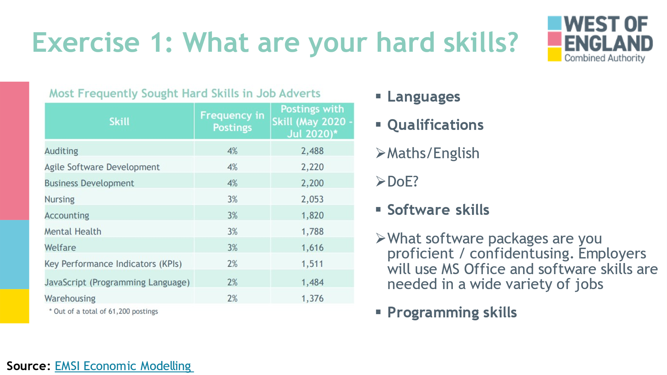

- We all have the hard skills shown on the right of this slide. From these write down an example of the hard skills you have for each category.
- Can you speak other languages?
- What qualifications do you have, not just your GCSE’s, do you have other qualifications or awards for example Duke of Edinburgh?
- Your English GCSE demonstrates to an employer that you have good communication skills both written and verbal. Your Maths GCSE demonstrates that you possess maths skills and nearly all employers will be looking for applicants that have both Maths and English GCSE’s
- Do you have any programming skills or experience of any software packages? (Highlight any software packages that are used within school/college
- Some of the subjects you are studying or have studied have given you hard skills that you can demonstrate to an employer. When you enter the workplace you continue to build and develop your hard skills particularly IT or Digital skills.
- Look at your skills in more depth here: https://beta.nationalcareers.service.gov.uk/

Notes:

Exercise Guide KS5 Tutorial
Exercise 2: What are your soft skills?
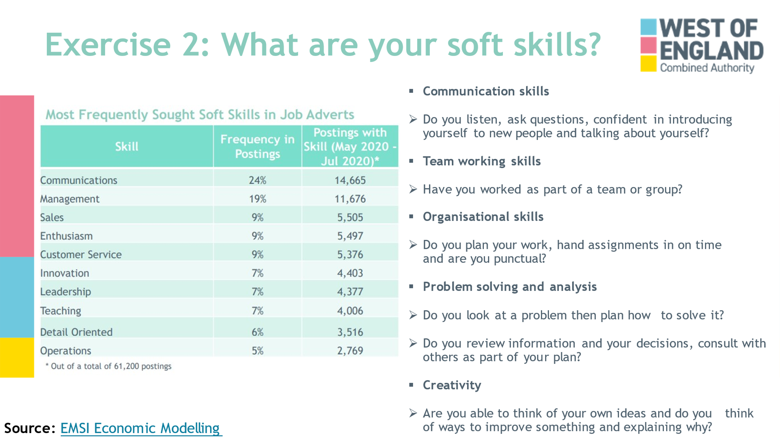

- you will have some of the skills on the right of this slide. These soft skills can be developed and built through your studies, through volunteering, through part time employment, through involvement with sports or other clubs or activities both in and outside of school / college.
- Write down the soft skills shown on the right then rate yourself from 1 to 5 as to how good you think you are for each. One is for “Need to Develop” this skill through to five which is ‘Strength for me”.
- Communication skills Do you listen effectively, ask questions and are you confident in introducing yourself to new people and talking about yourself?
- Team working skills Have you experience of working as part of a team or group?
- Organisational skills Do you plan your work, hand assignments in on time and are you punctual?
- Problem solving and analysis Do you analyse problems and develop a plan to solve them? Do you review information and/or think about your decisions and/or consult with others as part of that plan?
- Creativity Are you able to think of your own ideas and do you think of ways to improve something and explaining why?
- Look at your skills in more depth here: https://beta.nationalcareers.service.gov.uk/

Notes:

Exercise Guide KS5 Tutorial
Exercise 3: Demonstrating your soft skills to employers?
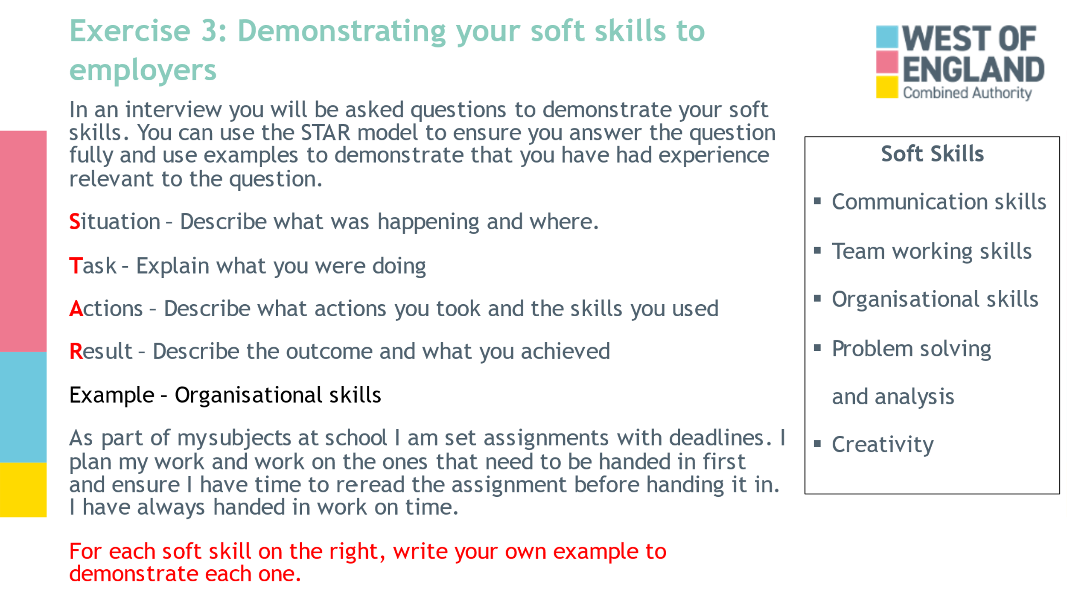

- As we have seen you have hard and soft skills already, but how would you demonstrate these to an employer?
- During an interview for a apprenticeship, a university or college course etc you will be asked to demonstrate your skills and experience. A good tool to help you do this is called the STAR method.
- Situation – Describe what was happening and where.
- Task – Explain what you were doing
- Actions – Describe what actions you took and the skills you used
- Result – Describe the outcome and what you achieved
- To answer a question in a concise and organised way structure your answer by using the STAR method.
- The slide shows and example of how you could use STAR to demonstrate your organisational skills
- For each of the soft skills on the right of this slide write your own example to demonstrate each one using the STAR method.

Notes:

