2019-20
SCHOOL
GATSBY
can
support

Gatsby Benchmark | Careerpilot can contribute through | How Careerpilot helps schools meet the Gatsby Benchmarks
 | 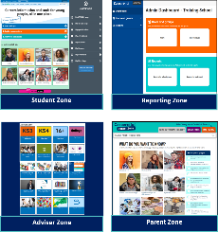 | The suite of Careerpilot tools can be central to a stable careers programme for Y7-Y13. Careerpilot provides information and advice to young people, the Reporting Zone enables schools to see the choices students make, which will help plan encounters with FE/HE and employers and Gatsby 3, The Adviser Zone has lesson plans, videos and resources to help schools plan and deliver a programme of careers education and the Parent Zone helps parents and carers get answers to career-related questions.
 | 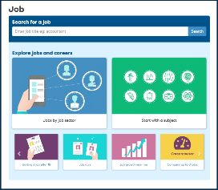 | The Careerpilot site ‘job’ section includes non-stereotyped videos and information on 19 job sectors linked to 57 sub sectors and 100s of job profiles, which include labour market intelligence nationally and locally. Job profiles also show where the jobs are regionally across the UK. The CareerometerTool enables young people to compare jobs. There is also a section on job growth. In the Adviser Zone we have ‘LMI in a Box’ section with LMI from LEPS by sector, for all South of England regions. The Course Search also provides LMI.
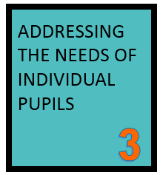 | 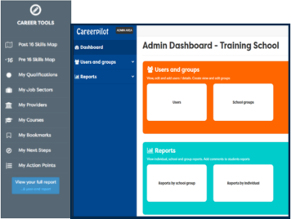 | Different parts of Careerpilot can be used in different year groups, linked to age, stage and key decisions. Career Tools enable registered students to explore and choose job sectors, qualifications, etc. which create a Career Tools Report. Choices can be viewed by the student and also by schools through the Reporting Zone. Reports can be used to target employer/FE/HE experiences to meet individual needs. Each year the student’s record is saved and moves with them. In the Adviser Zone there are models of whole school delivery and resources to help.
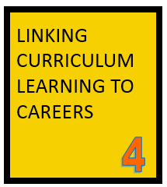 | 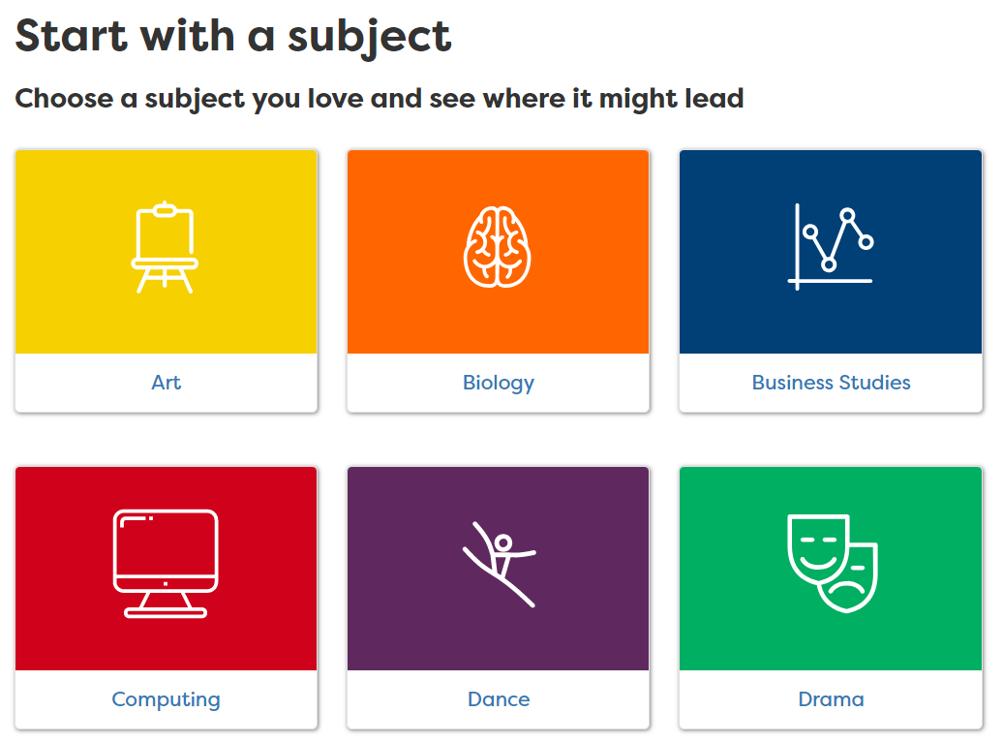 | Careerpilot has a ‘start with a subject’ tool which shows how each of 21 subjects can lead to sample jobs, apprenticeships, college and degree courses and useful MOOCS. New for 2019-20: Resources for subject teachers with lesson plans showing how a specific subject topic can link to careers, with videos, etc. There are over 1000 video case studies showing routes into a range of jobs, many which are non-stereotypical and some which can be searched by subject. This section is great for subject teachers to use in class.
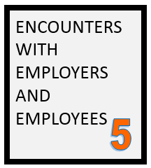 | 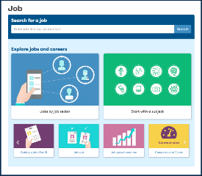 | Careerpilot has over 1000 video stories of people talking about their job roles and routes. The Pre and Post 16 Skills Maps enable students to record WEX, employer and FE/HE encounters and what skills they have learnt from these activities, which are added to their Skills Bank. Careers staff can use the Reporting Zone reports to plan encounters to meet students’ needs using information about students’ career interests, which are graded ‘exploring’ or ‘definitely interested’.
 | 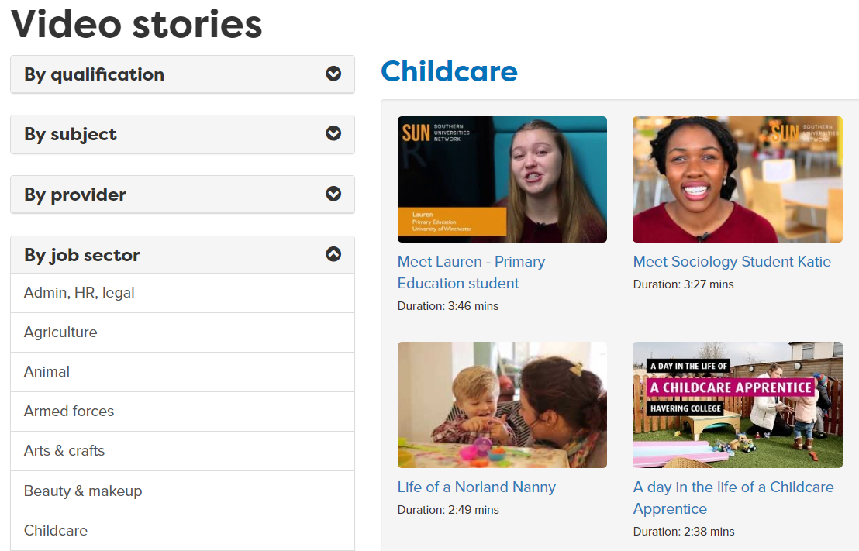 | Careerpilot has a section to help students plan their work experience, there are 800 job profiles to help students get detailed information about the role, expected skills, entry requirements and LMI. They can do the Skills Map as part of planning for WEX so they have list of their skills they can talk about at interview. In the Skills Map they can record their WEX experience and the skills it gave them after it has taken place and use this on CVs later.
 | 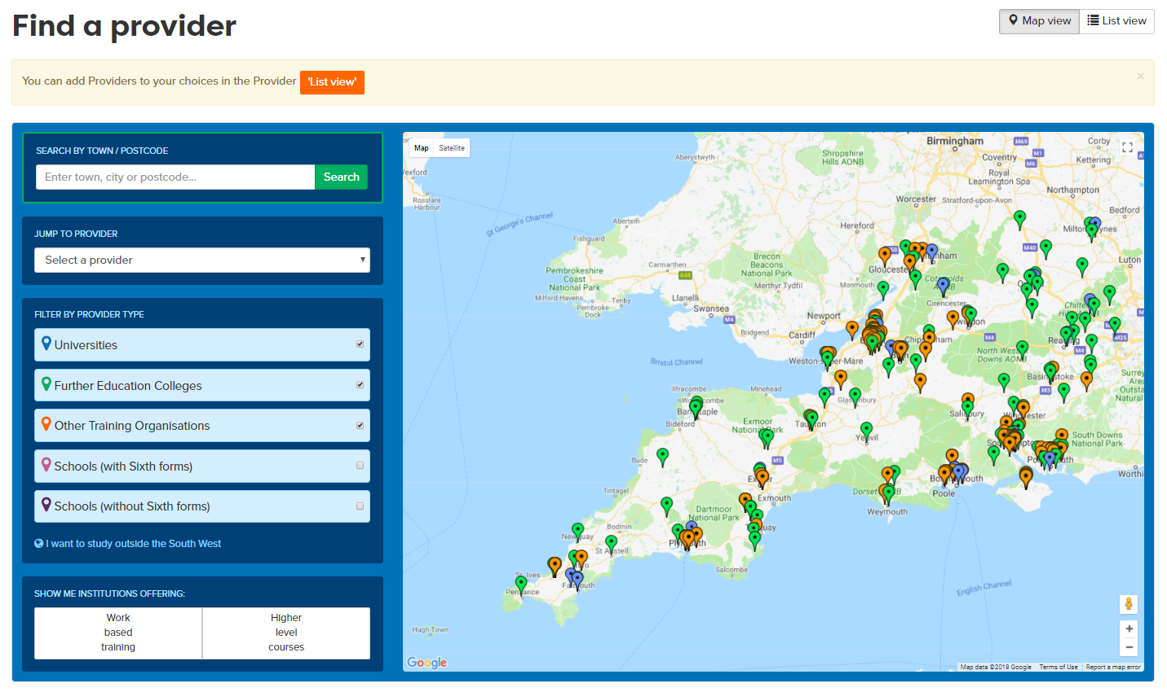 | Careerpilot has detailed information about ALL the study and training routes at 13/14, 16 and 18. A Qualification Planner helps them map their route through the levels. They can use the Course Search to find courses and Find a Provider has links to all schools, colleges, universities and many training providers in the South of England. The site has lots of videos from FE/HE students talking about study. The site has links to all open days.
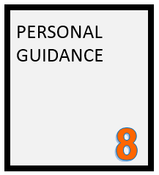 | 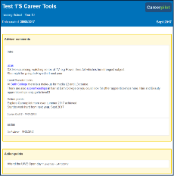 | Careerpilot can help students prepare for guidance if they complete the Career Tools before or during the meeting with an adviser. Guidance advisers can use the CTs report to inform the session and record reports and actions at the end of sessions on the Reporting Zone. The Adviser Zone includes suggested pre-guidance activities for different key stages related to age, stage and decision point. These are available to students through the Careerpilot home page under ‘activities to get you started’.

